**ASSIGNMENT ON SDLC MODEL**

1. Discuss the prototyping model. What is the effect of designing a prototype on the overall cost of the project?

ANS: The prototyping model is the pre- representation of the original project on the currently know requirement to understand the actual project .it is working replication of product. It is system developed method in which prototype is tasted overcome the actual problem . it is not the complete system and many of the details are not built in the prototype.

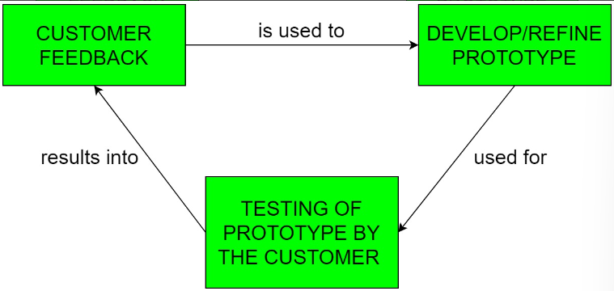

**Diagram of prototype model:**

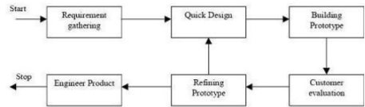

**Effect of design prototype model on over all cost of the project:**

Designing prototype model has some initial development costs, but it reduces the overall cost of the project by helping to come up with the exact output , so it is highly recommended to used prototype , it helps to understand drawbacks error during the initial stage so that the reconstruction, redesigning ,redeveloping cost is reduced and the designer get valuable feedback from the user early In the project , so that it help to reduce actual cost.

1. **Compare iterative enhancement model and evolutionary process model.**

|  |  |
| --- | --- |
| **iterative enhancement model** | **evolutionary process model** |
| 1 it does not attempt to start with a full specification of requirement ,fundamentl means change | 1] work with customer to understand system requirements and add new features as proposed by the coustomer |
| 2.repating the process on the same section of work and producing new version | 2] it is a combination of iterative and incremental model of sdlc |
| 3.repate the process design, implementation, evaluate . the whole product developed step by step .hence we can track the defect at early stage | 3] delivering the product in incremental process over time is the action done in this model |
| **Adv:-** we can only create a high level design of the application  1]define the design solution of whole product  2]design and built the skeleton version of that  3]evolved the design based on what we had been built. | **Adv:-**  a user gets a chance to experiment partially developed system.  It reduces the error because the core modules get tested thoroughly.  It is used when working on a technology is new and requires time to lear |
| Disadv:- not suitable for smaller project  Manegment complexity is more  More resourses required. | Sometimes it is hard to divide the problem into several versions that would be acceptable to the customer which can be incrementally implemented and delivered. |
| A usable product is released at the end of each cycle ,with each release providing additional functionality. | The Evolutionary development model divides the development cycle into smaller, incremental waterfall models in which users are able to get access to the product at the end of each cycle. Feedback is provided by the users |
|  |  |

**Q3 as we move outword along with the process flow path of the spiral model, what can we say about software that being developed or maintained.**

The product advances to a more complete state as work spirals outward, and the level of abstraction at which work is conducted decreases i.e., implementation specific work accelerates as we move further from the origin.

**Q4 explain the scrum agile methodology**

Agile scrum methodology is a sprint based project management system with the goal of delivering the highest value of stakeholders. It is used by companies for its ability to provide high end collaboration and efficiency of project based work. Agile and scrum are two different methods and can be used separately

Agile scrum methodology is the combination of the agile philosophy and the scrum framework. Agile means “incremental, allowing teams to develop projects in small increments. Scrum is one of the many types of agile methodology, known for breaking projects down into sizable chunks called “sprints.” Agile scrum methodology is good for businesses that need to finish specific projects quickly.

Agile scrum methodology is a project management system  that relies on incremental development. Each iteration consists of two- to four-week sprints, where the goal of each sprint is to build the most important features first and come out with a potentially deliverable product.  it encourages products to be built faster, since each set must be completed within each sprint’s time frame. It also requires frequent planning and goal setting, which helps the scrum team focus on the current sprint’s objectives and increase productivity.

**Q5 explain the utility of kanban CFD reports**

CFD is use to measure flow and analyse trends about a team's performance. a CFD chart as like a storyteller. It paints a picture of how workflows through your Kanban system within a period.

A CFD is a graphical representation of work as it flows through Kanban system. It is a time-based plot, with the time interval in the x-axis and the number of cards in the y-axis. The graph is divided into different colour bands, with the bands representing a state or column in Kanban board. The trajectory of the chart should be consistently upwards, with the bands staying more or less parallel and even in width.

**Patterns of kanban :-** Narrowing band

Widening band

To Do**band is wider than your**Done**band**

**Slope is flat**

******************************